A Usability Evaluation for Elderly and Middle Aged Users
using Structured Data Analysis
--- taking mHealth Application as Example

Huang Yi Fan, Kim Hyung Woo

Dongseo Univsersity
47 Jurye-ro, Sasong-gu
Busan, Korea
Gibbs_Huang@163.com

Abstract

Given the increasing number of older people, China has become an aging society. One of the main problem of in aging society is health problem of the elderly. Elderly and middle aged seniors who's stepping into elder life (they will be addressed as senior citizens aged from 50 to 70 in this paper), have more health problems than ever before. According to a survey of Chinese middle aged and senior citizens, the number of 50-70 aged users who’s suffered from angiocardiopathy and cognitive health disorders has quickly increasing. How to prevent disease and keep healthy life for elderly has been well valued. A mobile health application (mHealth APP) is a convient online service that provides personalized healthcare advice to those who require it, especially the older people and the middle-aged. However, few studies consider the experienced usability of mHealth Application with regard to the older and middle aged users using structured data analyses approach. This paper explored an approach of usability research based on structured data analyses and think aloud method. 10 middle-aged and older users were tested to evaluate the usability while using mHealth APP. Through the result of this study, we found middle aged and older users have not only concern with visualness and manipulation aspect, but also paid attention to the interaction aspect in the mHealth application.

Keywords- users aged 50-70 years old, mHealth application, usablity evaluation, structured data analyses.

I. Introduction

Since the fast development in both mobile communication and wireless technologies [1], mobile health services, which can be called ‘mHealth’ , has become a new trend in healthcare. Mobile health services are typical example which aim to provide medical and healthcare service to both professionals and for consumers. However, the internet digital services development has been weighted in favor of youth market, thus obtaining healthcare service via mobile phone for elderly and middle aged people is more important [2].
China, which has the largest population of older citizens in the world, has become an aging society. A study on healthcare for elderly Chinese shows that roughly 79.5% of people over 60 years old have at least one chronic disease, almost 50% have at least two, and more than 25% have three or more [3]. In addition, middle age is the closest pre-age group to elderly people. In another survey for Chinese middle aged and elderly, by 2016, the number of 50-70 aged users who’s suffered from chronic disease and cognitive health disorders has the fattest speed in growth comparing with other age groups [4]. Therefore, finding an effective solution to relieve the heavy burden of providing healthcare for both the elderly and middle-aged people is an urgent concern.
The benefits of mHealth applications have been widely accepted, however, there is few studies has focused on mHealth usability. In the available studies, most lack methodological standards. Also, qualitative data analyses in mHealth studies typically lack a structured approach, making study difficultly in reproductions. Mattias et.al has recommended an analyses approach using the Usability Problem Taxonomy (UPT) [5] to solve this problem by which may result in more comprehensive identification of usability problem upon user-centered data.
This study aims at evaluating the experienced usability by middle aged and older users, who’s aged 50-70 years, in using a mHealth application. Meanwhile the feasibility of structured analyses using UPT will be validated through PSSUQ during this usability evaluation. This study is beneficial in providing specific guidelines for improving user experiences in mHealth applications for users aged 50-70 years in China.

II. Literature Review

A. The data analysis of usability evaluation

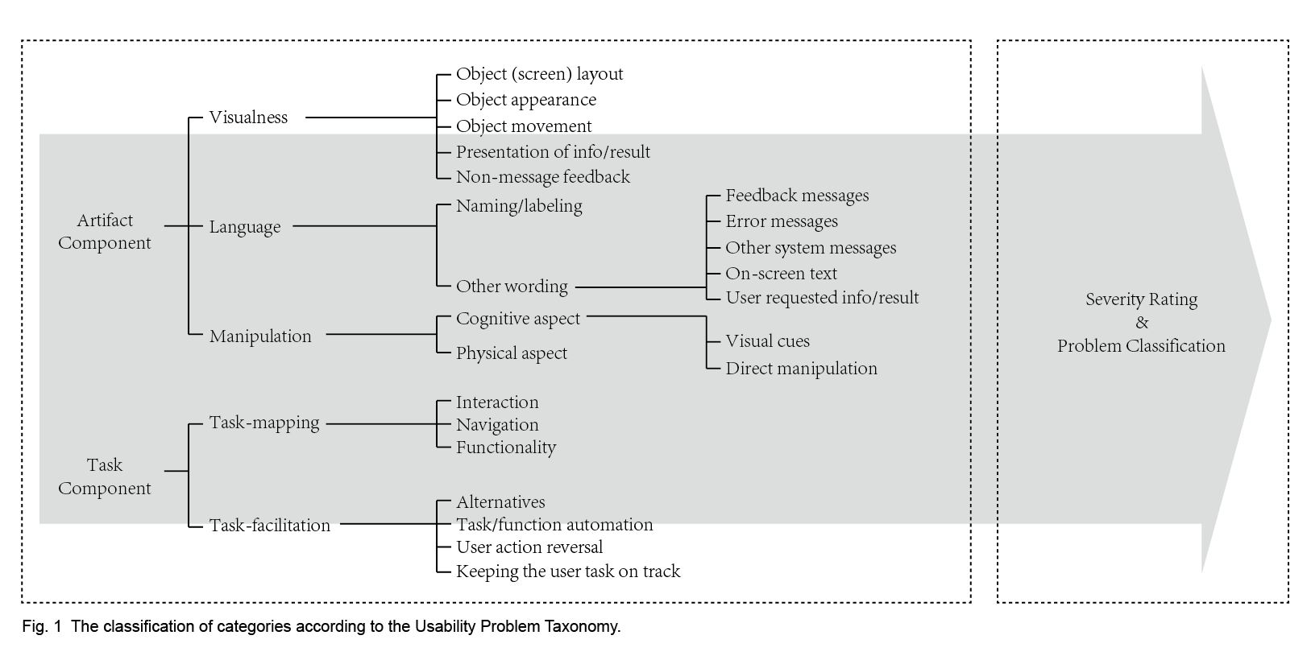
Usability is now widely recognized as an important software quality alongside other aspects such as functionality and reliability. The usability issue of computer systems had become important because of the both growth of application domain and user population. Since such human behavior research often produces reams of data that can take significant time to analyze, researchers must organize and reduce these data in order to quickly perform their analysis and proceed with improving the products. Normally, the analyzed data in usability evaluation progress can be classified into Quantitative/Qualitative or Objective/Subjective data.

B. Structured Data analysis

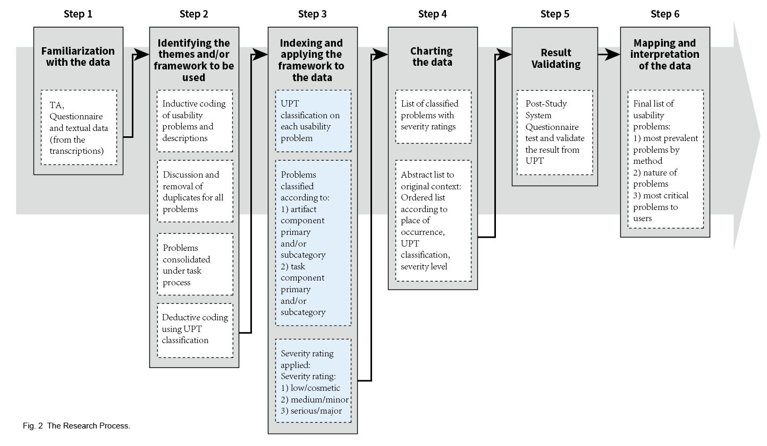
Recent reviews of mHealth usability studies point to the need for more detailed and formative studies [6]. Since the quantitative methods such as the Post-Study System Usability Questionnaire (PSSUQ) lacks of open and abundant information from the users, qualitative method such as heuristic evaluation [7] and cognitive-walk through [8] were popular in recent usability researches. However, the main shortcomings of qualitative research methods are a lack of standardization in data analytic techniques, meaning that replicating the results of analyses can be difficult. The UPT is based on the notion that usability problems should be examined from two perspectives: the task-artifact approach proposed by Carroll et al. [9] and the Object-Action Interface Model by Shneiderman [10] to enhance problem definition. The Detail components of UPT can be seen in Fig 1. Although UPT is not well known at present, it did provide detailed classification method based on mobile application user experience. Thus, authors think UPT a useful tool in structure data analysis of usability evaluation.

III. Material and Methods

A. The evaluated application

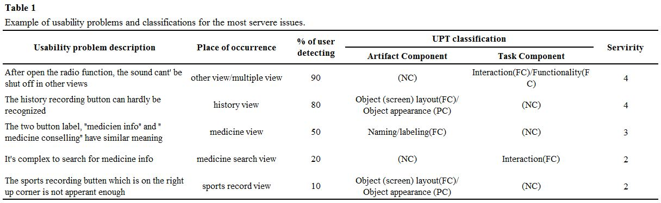
The application evaluated in this study is an interactive, multi-functional application for the users who has diagnosed with diabetes designed as a personal self-management tool. The system consists of lots of functions like blood pressure recording, diabetes information, doctor online consulting, users online social network etc. The application was developed by a Chinese company collaborated with Mayo Clinic, a USA research center which has been founded 150 years with fame in health care services throughout the world. In this study, we concentrated our evaluation mainly on the interface of the solution because of its inherent complexity and because it had no previous usability evaluation.

B. Study sample and setting

According to Neilson’s research result, the 80% of the usability problem can be found by testing no more than 5 users [11]. In order to cover more usability problem regarding with the budget, ten users were randomly selected from Shanghai University for the Elderly on using mHealth application by android based smartphone and invited to take part in our usability evaluation. Inclusion criteria for our usability study sample included (1) users diagnosed with diabetes (2) user aged from 60-70 years old (3) no cognitive impairment (4) familiarity and some knowledge and use of smartphone; and (5) the ability to speak and understand the Chinese language. Users had no previous exposure to the mHealth application evaluated in our study. The evaluation sessions were conducted in a quiet classroom setting at Shanghai University for the Elderly.

C. Usability test with think aloud protocol

Think Aloud is a usability assessment method commonly employed to determine users’ thoughts and opinions while they perform a list of specified tasks with a system. The method originated in 1984 in psychology when Simon and Ericsson thought of verbal reports as data. The focus is on understanding users’ decision making processes and on how users experience the system in their own words. Authors think that Think Aloud provides complete and detailed descriptions of users’ thought processes during system interactions.

D. Study procedure

First, patients were asked for informed consent. Then, users were walked through the different steps of the evaluation procedure and asked if they had any questions. The evaluation started with users filling out a brief demographic questionnaire. Topics included age, gender, educational level, occupation, and salary.
Next, standardized training was performed to simulate an actual user educational process. This was important to decrease individual variability and to ensure that users all had the same information about the system.
Afterward, Think Aloud protocol and UPT was used in this research step by step according to the Fig.2. The complete testing procedure for all the steps averaged approximately 30 minutes.

IV. Results

A. Usability problems addressed by UPT

At the beginning, A total of 175 usability problems were found by the ten users during the usability evaluation progress. After consolidating the problems, 48 characterized usability problems were classified. The average severity rating for the whole application was 2.73 in 4.

Fig.3 The Number of the Occurrence of Different Usability Problem Classification according to UPT

According to the number of the occurrence of usability problem classification by UPT, the object appearance had the highest number of problem occurrence by 53. Cognitive aspect had 44. Interaction had the third highest occurrence with 38, and navigation, functionality and object layout had 34, 30 and 27 by sequence (Fig. 3). The other classified problems have much less occurrence.

B. PSSUQ results

A standard post study system usability questionnaire(PSSUQ) was conducted to validate the results of the usability evaluation in this study. According to the static results, The Overall usability problem severity mean value was 4.33±0.4.

V. Discussion

A. Usability problem types and classifications

According to the static result by PSSUQ, the severity rate by UPT is generally validated ((4.33±0.4)/5 by PSSUQ (see Table 2), 2.73/4 by UPT). Since the severity rate is more than 70% overall, authors consider the evaluated application has server usability problem to the users who’s aged 50-70.
In the consolidated 48 characterized usability problem, the Other Views had the highest severity ratings. This indicates lack of controlling object can negatively affect the user experience when user unable to control the application statue. Main View and Diet Record View all had usability problems with high severity rating since the main function button was not obvious enough. This may cause by misunderstanding of users’ cognitive model during the layout design process.
Based on the UPT classifications, the number of the occurrence of usability problem classification also shows that the users between 50-70 years old are sensitive on object appearance and cognitive aspect with has been known in other elderly research studies. In addition, users also pay lots of attention to interaction aspect which is new phenomenon in elderly usability research. It indicated that the users aged 50-70 years old may need more obvious and adequate stimulation in interaction design.

B. Method Contributions

Structure data analyses is convenient for finding usability problems. Efficient resource can be obtained by Think Aloud protocol with no more than 10 users. This is consistent with past study as Nielson had recommended [11].
Authors found the UPT is highly valuable in usability evaluation. By UPT classification, each problem can be determined on a more detailed as well as a hierarchical level. In this way, the result was well described and we could arrange these problems into a understandable pattern. In addition, adding a severity rating assists output the frequency of the problem, coding the occurrence helps deeper understanding in user cognitive model, these all would be helpful in future research and solutions development.

C. Limitations and future research

The sample size of 10 users was small but fitting for usability and methods feasibility testing. Authors found smaller sample do have advantage in limited budget research and it’s also proved to be sufficient. The overall usability evaluation process maybe a little short, and users would probably operate better after more practice. However, most users will give up the product if the design can’t provide satisfied experience in 5 minutes. Future research might include testing with larger samples, by which a user experience characteristics framework can be formed according to users aged 50-70 years old.

VI. Conclusion

Recent systematic reviews of mHealth self-management tools in general and for diabetes shows the necessary for more studies on users’ interaction and usability, especially re-understand the user experience of elderly and middle aged users. Thus, a more standardized, structured and reproducible framework need to be built up to work in usability evaluation to provide more persuasive evidence. This study provides an example of a structured data analysis approach which is designed for both data collection and data analyses. With a more comprehensive usability problems description, the structured data analyses allowed reproducible steps and data validation, a method of determining the most severe problems for users.
Think Aloud protocol and structure data analysis approach fit well into each other in this research. Authors recommend the using both of them in usability evaluation. User group-orientated research is also recommended for in-depth usability research.

References

- Z. Deng, “Understanding public users’ acceptance of mobile health service”, International Journal of Mobile Communications vol. 11, pp. 351–373. April, 2013.
- K. Leena, L. Tomi, R. Arja, “Intensity of mobile phone use and health compromising behaviors: how is information and communication technology connected to health-related lifestyle in adolescence”, Journal of Adolescence vol.28, pp.35–47, 2005.
- R. Hui, H. Zhang, R. Zhang, Y. Liu, “An evaluation of elderly people’s health status in China”, Journal of Practical Nursing, vol.18, pp. 57–58, July, 2002 (in Chinese).
- W. Chen, Z.N. Li, Y.M. Chen, “A report on Chinese middle aged and elder citizens”, Sun Yat-Sen University, School of Public Health, 2016 (in Chinese).
- M. Georgsson, N. Staggers “An evaluation of patients’ experienced usability of a diabetes mHealth system using a multi-method approach”, Journal of Biomedical Informatics, vol. 59, November 2015.
- C.R. Lyles, U. Sarkar, C.Y. Osborn, “Getting a technology-based diabetes intervention ready for prime time: a review of usability testing studies”, Curr. Diab. Rep. vol.14, pp. 534, October, 2014.
- J. Nielsen, Usability Engineering, xiv, Academic Press, Boston, 1993. pp, 358.
- P.G. Polson et al., “Cognitive walkthroughs – a method for theory-based evaluation of user interfaces”, Int. J. Man Mach. Stud., vol. 36, pp. 741–773, May, 1992.
- J.M. Carroll, W.A. Kellogg, M.B. Rosson, “The Task-artifact Cycle, in: M. Carrol (Ed.), Designing Interaction: Psychology at the Human–Computer Interface”, Cambridge University Press, New York, pp. 74–102, 1991.
- B. Shneiderman, “Designing the User Interface: Strategies for Effective Human– Computer Interaction”, Addison Wesley Longman, Reading, Mass., 1998.
- J. Nielsen, T.K. Landauer, “A mathematical model of the finding of usability problems”, Proceedings of the INTERACT ’93 and CHI ’93 Conference on Human Factors in Computing Systems, ACM, Amsterdam, The Netherlands, pp. 206–213, 1993.

